**Experiment Name**: Working with basic Linux command.

**Aim and Objectives:** Linux is open source OS.to operate Linux OS appropriately Linux command is very important. The main goal of this experiment how to work Linux command know about its benefits.

* + To know about Linux command.
  + To work with Linux command.
  + To know how to use Linux command in terminal

**Experimental Setup:**

**$ whoami :** It shows who logged on this system.

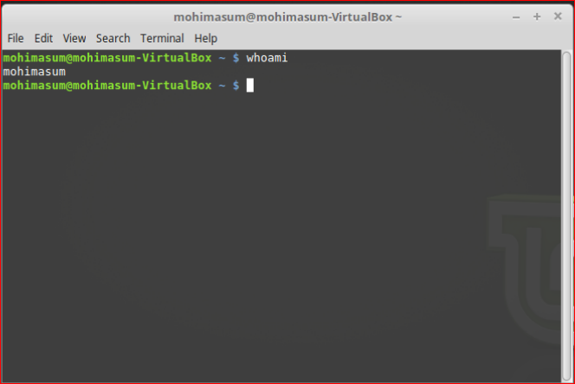

**$ hosname** :It tells on which machine you are.

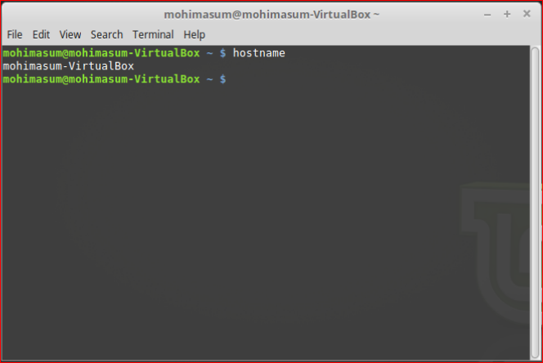

**$ pwd** :Shows the path of current working directory

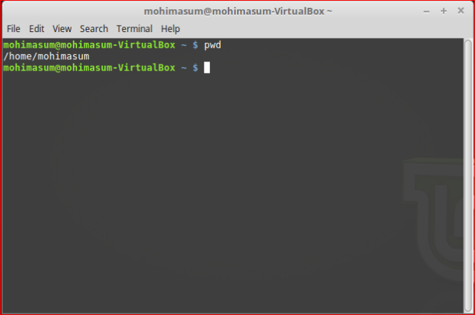

**$ ls** : Displays the list of files in the current working directory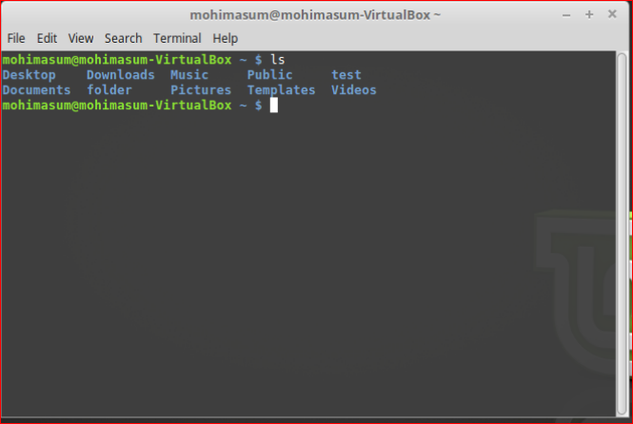

**$ mkdir <dir_name>:** Creates a directory with specified  'dir_name'.

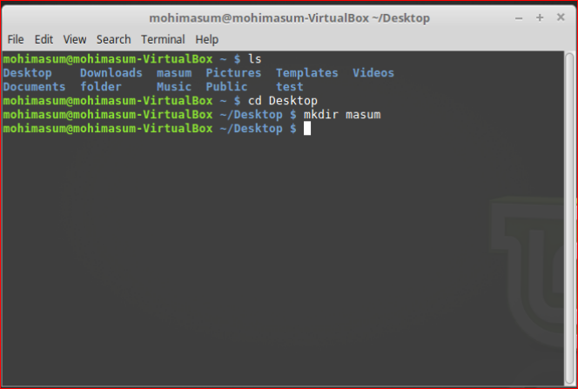

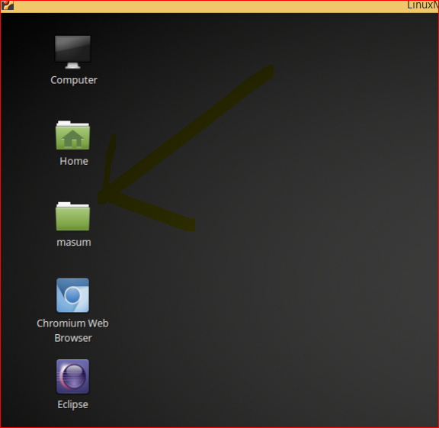

After Removing the file .

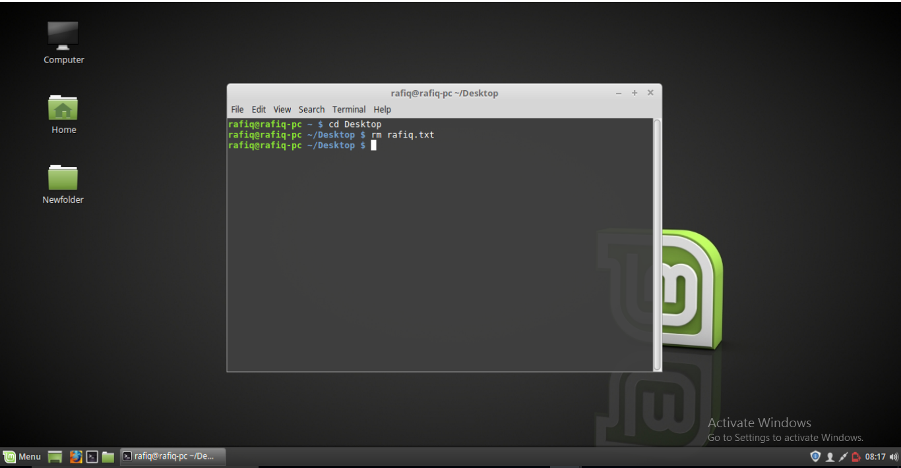

**$ mv <name1> <name2> :**Renames the directories or files.

Before renaming.

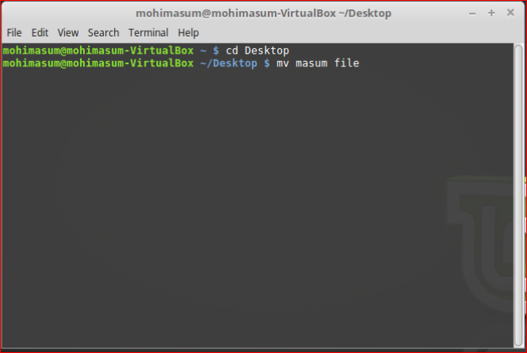

After renaming.

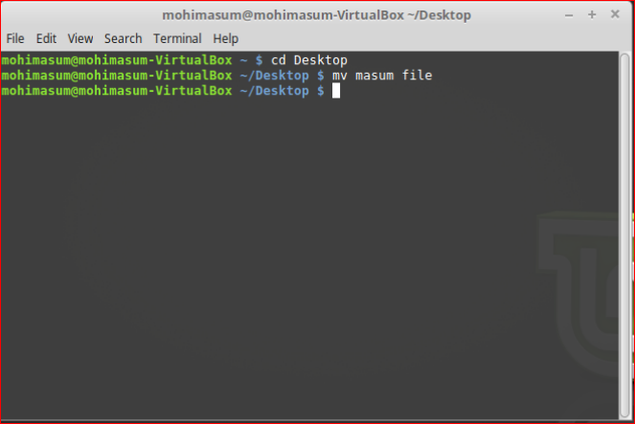

**Conclusion:**  Unlike windows OS Linux OS is command-based OS. In this lab we have learned various type of Linux basic command such as create directory and removing directory and so on. So this is very important things that to familiar with Linux command .if we learned Linux command it will be easy to work with Linux OS.